Additional files
File name: Additional file 1
- Title of data: The ARRIVE Guidelines Checklist.
- Description of data: The ARRIVE Guidelines Checklist.

File name: Additional file 2
- Title of data: Different species of ectoparasites.
- Description of data: Different species of collected ectoparasites from rodents; C. mesghalii (a), E. oschanini (b), N. t. turkmenicus (c), N. ziarus (d), X. nuttalli (e), R. sanguineus (f), Polyplax spp. (g), Hirstionyssus sp. (h) and D. sanguineus (i) (Field specimens)

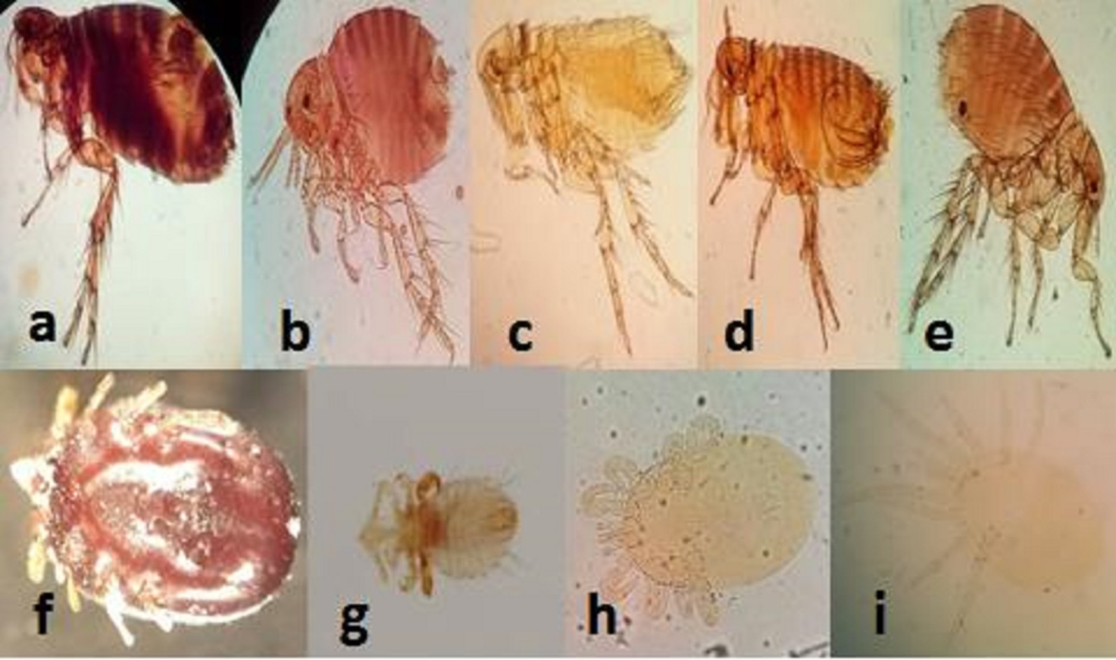

File name: Additional file 3
- Title of data: Electrophoresis of the second-round (nested) PCR products.
- Description of data: Agarose gel (1.5%) electrophoresis of the second-round (nested) PCR products. L1: 50 bp ladder, P: a positive control (Standard strain L. major), N: a negative control (distilled water), lanes 1-4 respectively: L. major, L. turanica, mixed infection of L. major and L. turanica and mixed infection of L. major and L. gerbilli (the infected smears of ear lobes of the rodents), lane 5: mixed infection of L. major and L. gerbilli, lane 6: mixed infection of L. major, L. turanica and L. gerbilli, lanes 7-11: L. major and L2: 100 bp ladder. Lanes 1-4 are from smears of ear lobes of the rodents and lanes 5-11 were isolated from X. nuttalli, E. oschanini, C. mesghalii, N. ziarus, D. sanguineus, Hirstionyssus sp, and R. sanguineus respectively.
